Report: Assignment 7

I have solved this assignment with stan model and Python. I solved this for 100000 samples and 1000 samples for warm up.I have used Gelman’s approach for this, because it is more intuitive for me to have separate priors for kids and adults.

I ran the model without any normalization and parameterization. For first many instances my model ran without any error. Then once I got the following error, it kept recurring.

Error:

WARNING:pystan:1310 of 99000 iterations ended with a divergence (1.32 %).

WARNING:pystan:Try running with adapt_delta larger than 0.8 to remove the divergences.

WARNING:pystan:Chain 1: E-BFMI = 0.137

WARNING:pystan:E-BFMI below 0.2 indicates you may need to reparameterize your model

Then I tried running it after reparameterization of theta, but it showed an error of scale parameter of lognormal distribution being infinite.

1.  Give an interpretation of 𝜃0  and 𝜃1  in plain text. Explain to a non-statistician what these two parameters mean.

𝜃0 and 𝜃1 are the intercept and slope parameters respectively, that define a linear relationship between th number of response as the predictor variable x, and the response time as predicted variable y. The model gives the possible credible values of 𝜃0 and 𝜃1 . Therefore, the model output is not the reaction time, but estimated parameters that would give a reaction time for a given number of response.

## 2. Give an interpretation of all the phi:s and mu:s in plain text. Explain to a non-statistician what these parameters mean. Try to do it in the original scale, i.e. in terms of average reaction time rather than log reaction time.

𝜇0, 𝜙0, 𝜇1 and 𝜙1 provide the prior distribution for 𝜃0 and 𝜃1. 𝜇0 and 𝜇1 are the mean values of 𝜃0 and 𝜃1 respectively for adults. 𝜙0 and 𝜙1 are the effects added to the mean for being a child. A negative 𝜙0 and 𝜙1 means that the response time is decreasing with number of responses, i.e. they are learning faster , while a positive 𝜙0 and 𝜙1 mean a higher response time and hence slower learning than adults.

3. Provide the expected reaction time for the first attempt (x=1) and the fifth attempt (x=5) for the first individual (Oliver), third individual (Jesper) and fourth individual (“the dude”)

Below are the plots for the slope and response times for the first and 5th attempts of participant number 1, 3 and 4.

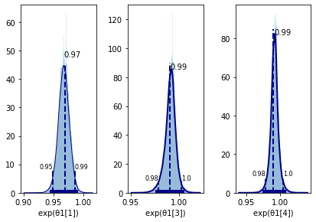

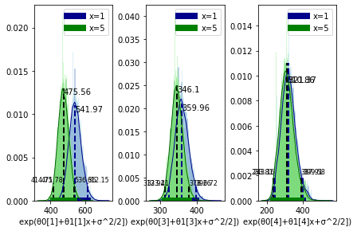

4. Discuss possible model improvements to our model.

### What would happen if x goes to infinity?

If x goes to infinity, the reaction time will eventually diminish to 0, which is unrealistic. The reaction time can in practice only reduce to a certain limit and then remain approximately constant. Also, the available data is only upto a maximum of around 20 attempts. Based on this data, it is not possible to get a realistic estimate of infinite number of attempts.

My understanding is that, since it is our prior belief that the reaction time can go down to, say a 100 ms, this limitation should be specified in the prior. If there is not enough data for what happens after 20 attempts, it should be strongly affected by only the prior belief. The prior on 𝜃0 and 𝜃1 could be defined in such a way that the reaction time does not go below a certain value.

### How can we improve the model?

1. As discussed in the lectures earlier, it would be informative to have separate sigmas for children and adults. It would help analyse the variation in response levels of children and adult. My intuitive belief is that adults might have a larger sigma than children.
2. The model hierarchy can be made more complex for example grouping the response times based on the test device, time of the day, gender or more age categories.
3. The linear trend on reaction time with response number can be explored more to fir other distributions that describe the data better.
4. Changing the prior distribution for example, as mentioned before to accommodate the reaction time to not decay below a certain level.

5. Notice that your sigma has decreased in Assignment 7, but are the same in 6 and 5. Why is that do you think?

In assignment 5 and 6, sigma was the deviation from the mean reaction time for the entire group. It was a larger spread of data. There still was substantial change in the reaction time with increasing attempt, but rather than that being an expected behavior, it was accounted as deviation through sigma. In this assignment, sigma is the spread from the regression line defined for each individual. The variations in the value with increasing number of attempts are already accounted for by the model. Sigma records the spread from the individual variations for each response number which are now expected. Therefore, the decrease in sigma.

6. When reporting your findings, you may follow section 25.1 on how to report Bayesian analysis using MCMC. However, this is too cumbersome for this Assignment. My suggestion is that you read section 25.1 and create the same bullet list as Kruschke has. In your bullet list, explain what you have not done according to Kruschke and similarly what you have done.

1. Motivate the use of Bayesian analysis:

In this assignment, Bayesian Analysis can probably be not motivated very strongly, in terms of the use of prior and likelihood because we are using uniform priors. However, in terms of analysis it is very useful in this case, as we get to group the data in different categories and we are able to analyse the group behavior and the distance of categorical behavior from the group. In the last assignment Bayesian also is very useful for the estimation of parameters in a linear model.

1. Clearly describe the data structure, model and parameters.

This part has been explained in sections 1 and 2 of this assignment.

1. Clearly describe and justify the prior

This can not be reported properly in this case, as we focused more on the methodology of doing a Bayesian Analysis with an example data.

1. Report the MCMC details

The run was inconsistent for me. Initially, the model could run multiple times without an error. Then it starts to throw an error of iterations ending with divergence. I tried to fix it with reparametrization and changing the adapt_delta to a larger value. It is now taking a long time to run and the issue is still unresolved. The plots I have are from the previous successful runs without reparametrisation.

1. Interpret the posterior

The posterior interpretation will include the analysis of the learning rate of kids and adults with the response number.

1. Robustness of the posterior for different priors

This model was tested with only one type pf prior.

1. Posterior predictive check

I have not been able to plot credible regression lines with data as my model has stopped running. I am still turning in the report since it is the deadline. I will try to post this if I get it working.

1. Power analysis

Not included in this report.



Error

WARNING:pystan:10250 of 99000 iterations ended with a divergence (10.4 %).

WARNING:pystan:Try running with adapt_delta larger than 0.8 to remove the divergences.

WARNING:pystan:Chain 1: E-BFMI = 0.19

WARNING:pystan:E-BFMI below 0.2 indicates you may need to reparameterize your model